# VA UX Guide Content Assessment

## Overview

The content on the VA UX Guide website, in general, adheres to grammar rules and is consistent in style. This produces a professional tone and boosts the credibility of the content.

Content on some pages is dense and requires close reading to understand. This style can be appropriate once visitors have reached a detail page, but should be avoided on the home page and landing pages. Even on detail pages we should facilitate scanning as much as possible to better engage readers and improve quick comprehension.

Using web content best practices, we could:

* Turn key points into bulleted items
* Use active voice
* Shorten sentences
* Break long paragraphs into shorter ones
* Add more subheads

## Content Examples and Recommendations

Home Page 2

User Persona Library 6

Scenarios of Use Library 8

Methods Library 10

Heuristic Evaluation 12

## Home Page

<https://veteransaffairsuxguide.com/>

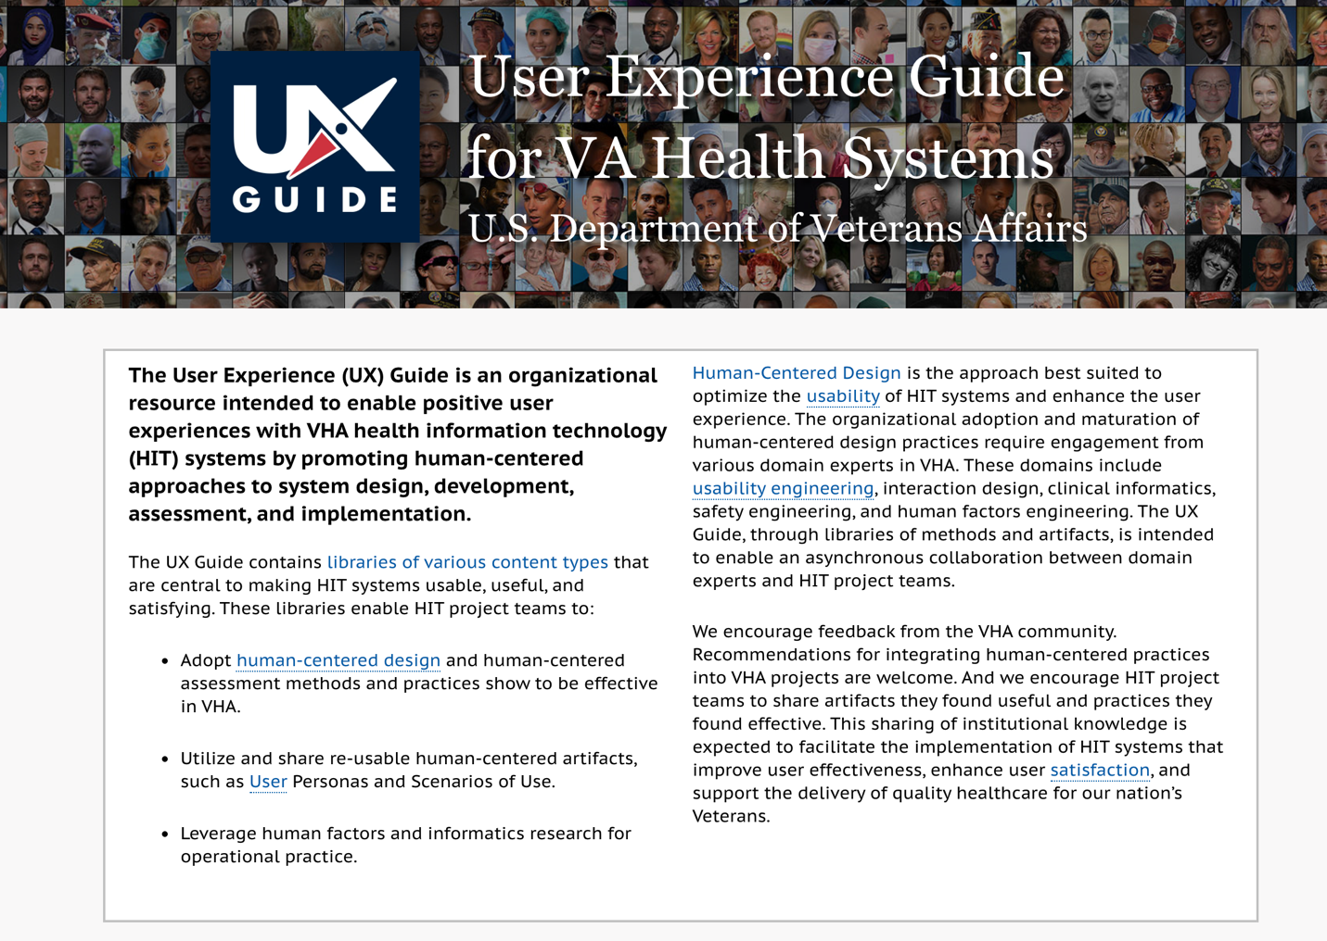

The content on the home page could be shortened to better emphasize the most important points. Use shorter sentences and paragraphs and add more subheads to improve scannability. Allow visitors to drill down for details.

Example:

**The User Experience (UX) Guide is an organizational resource intended to enable positive user experiences with VHA health information technology (HIT) systems. The guide promotes human-centered approaches to system design, development, assessment, and implementation.**

The UX Guide contains [libraries of various content types](https://veteransaffairsuxguide.com/#uxlibraries_section) that are central to making HIT systems usable, useful, and satisfying.

These libraries enable HIT project teams to:

* Adopt [human-centered design](https://veteransaffairsuxguide.com/glossary/human-centered-design/) and human-centered assessment methods and practices show to be effective in VHA.
* Utilize and share re-usable human-centered artifacts, such as [User](https://veteransaffairsuxguide.com/glossary/user/) Personas and Scenarios of Use.
* Leverage human factors and informatics research for operational practice.

## The Case for Human-Centered Design

[Human-Centered Design](https://veteransaffairsuxguide.com/#hcd_section) is the approach best suited to optimize the [usability](https://veteransaffairsuxguide.com/glossary/usability/) of HIT systems and enhance the user experience.

The organizational adoption and maturation of human-centered design practices require engagement from various domain experts in VHA. These domains include [usability engineering](https://veteransaffairsuxguide.com/glossary/usability-engineering/), interaction design, clinical informatics, safety engineering, and human factors engineering. The UX Guide, through libraries of methods and artifacts, is intended to enable an asynchronous collaboration between domain experts and HIT project teams.

## Tell Us What You Think

We encourage feedback from the VHA community. Recommendations for integrating human-centered practices into VHA projects are welcome. And we encourage HIT project teams to share artifacts they found useful and practices they found effective. This sharing of institutional knowledge is expected to facilitate the implementation of HIT systems that improve user effectiveness, enhance user [satisfaction](https://veteransaffairsuxguide.com/glossary/satisfaction/), and support the delivery of quality healthcare for our nation’s Veterans.

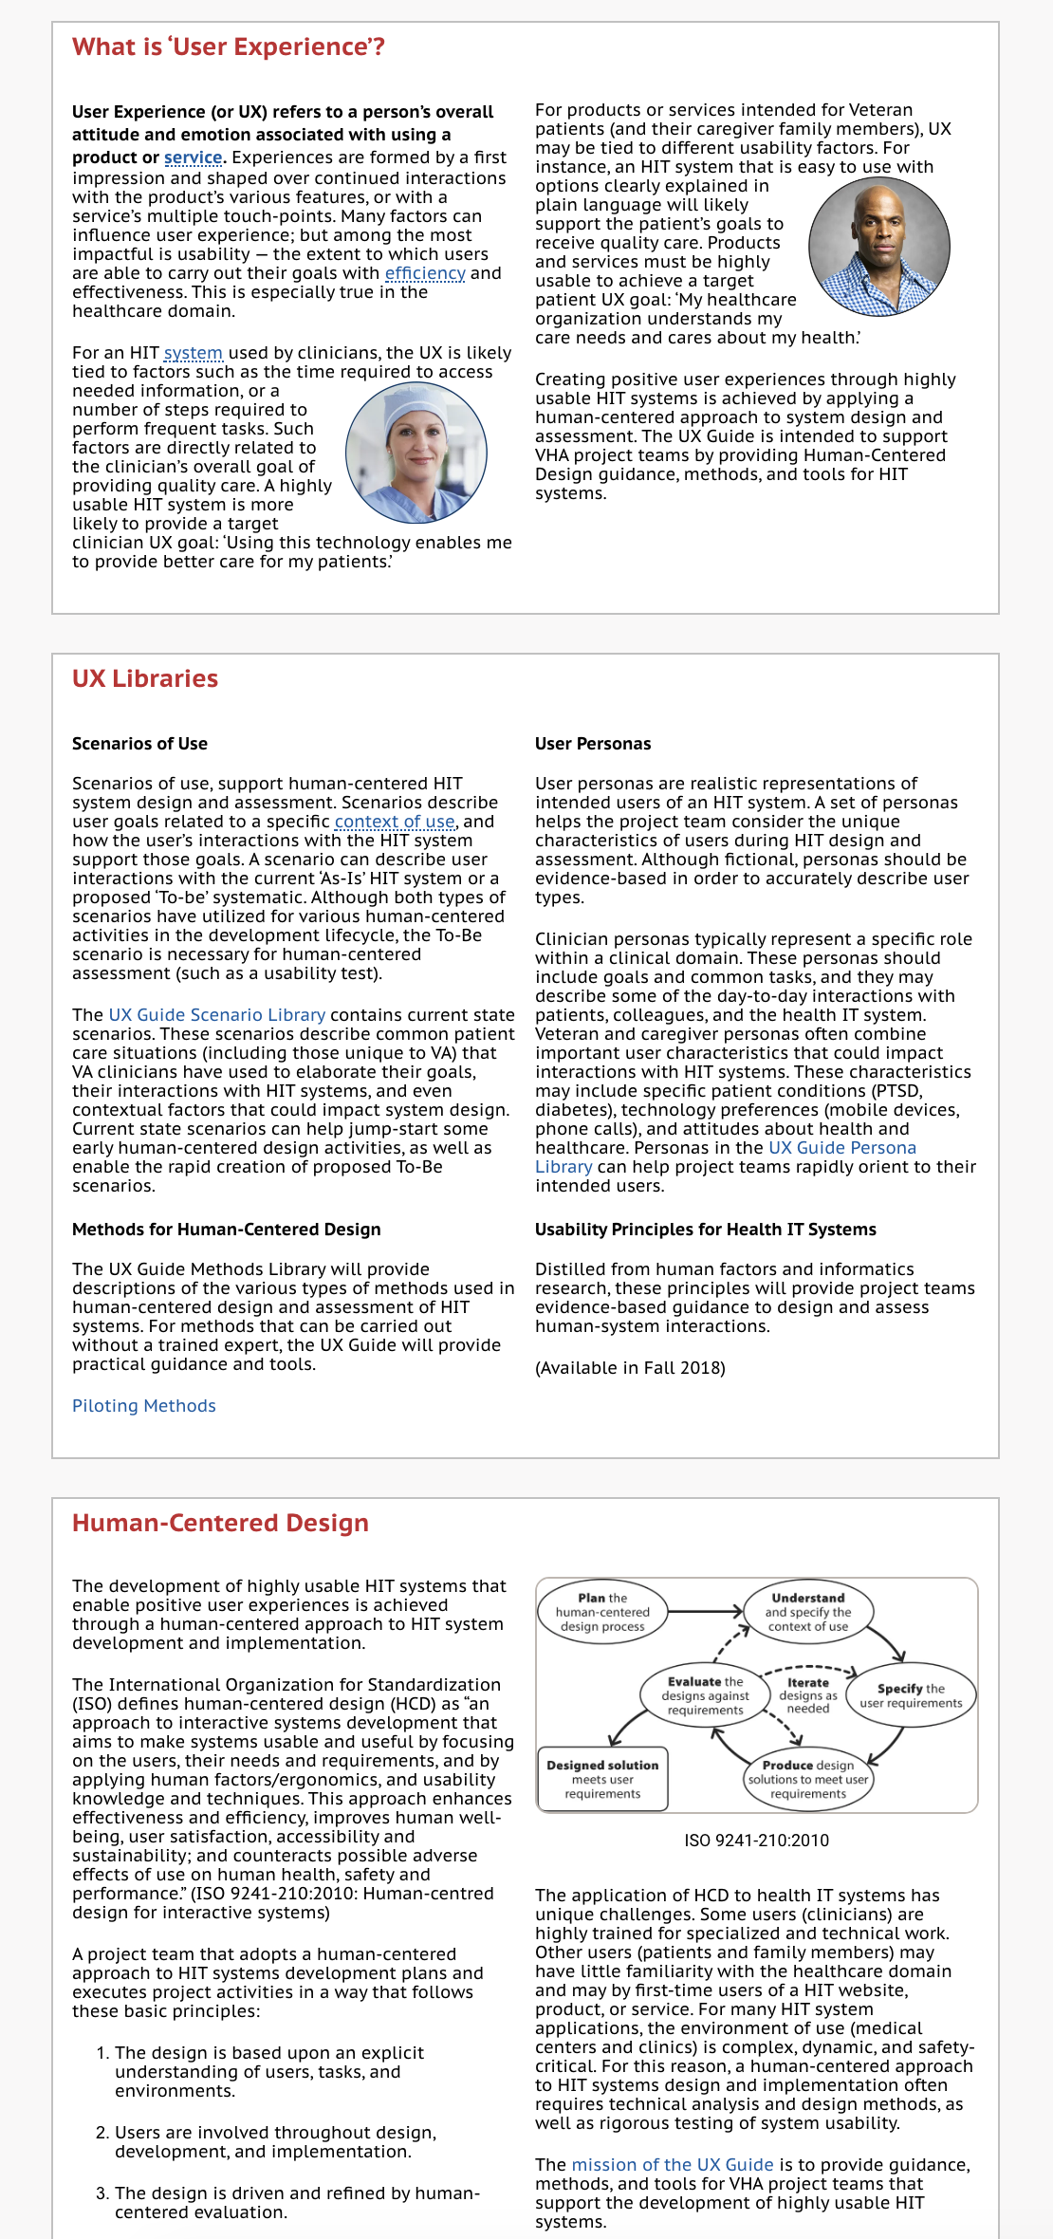

The home page has a lot of content. Important details could be lost. Summarizing and moving the details to interior pages could increase engagement.

Instead of the long descriptions of UX Libraries, we could use the short descriptions found on the Libraries landing page.

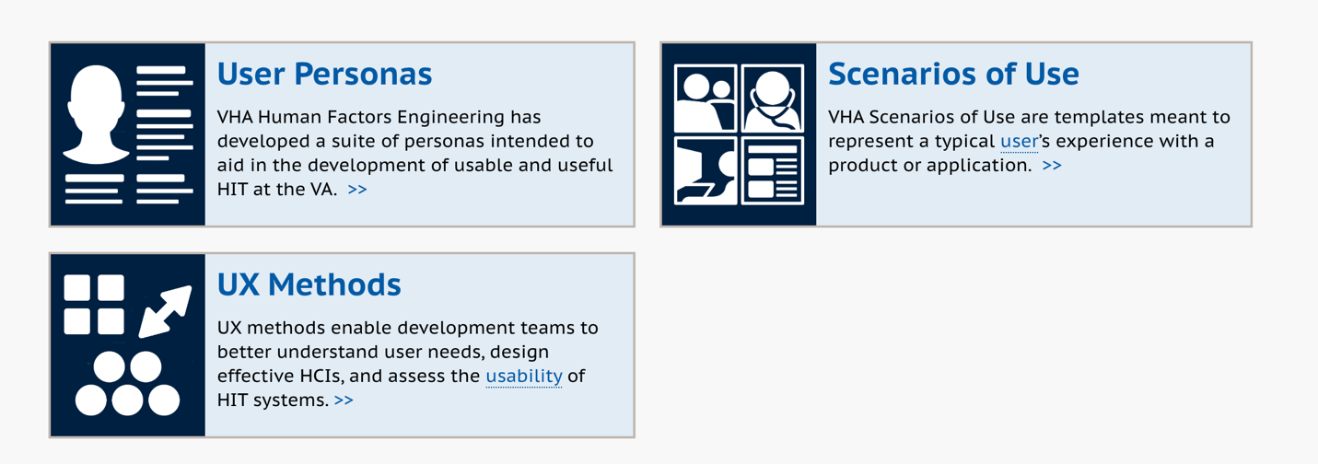

The longer descriptions could be integrated on the landing pages for each content type to help users better understand what that content types are, once they’ve clicked through.

## User Persona Library

<https://veteransaffairsuxguide.com/libraries/user-personas/>

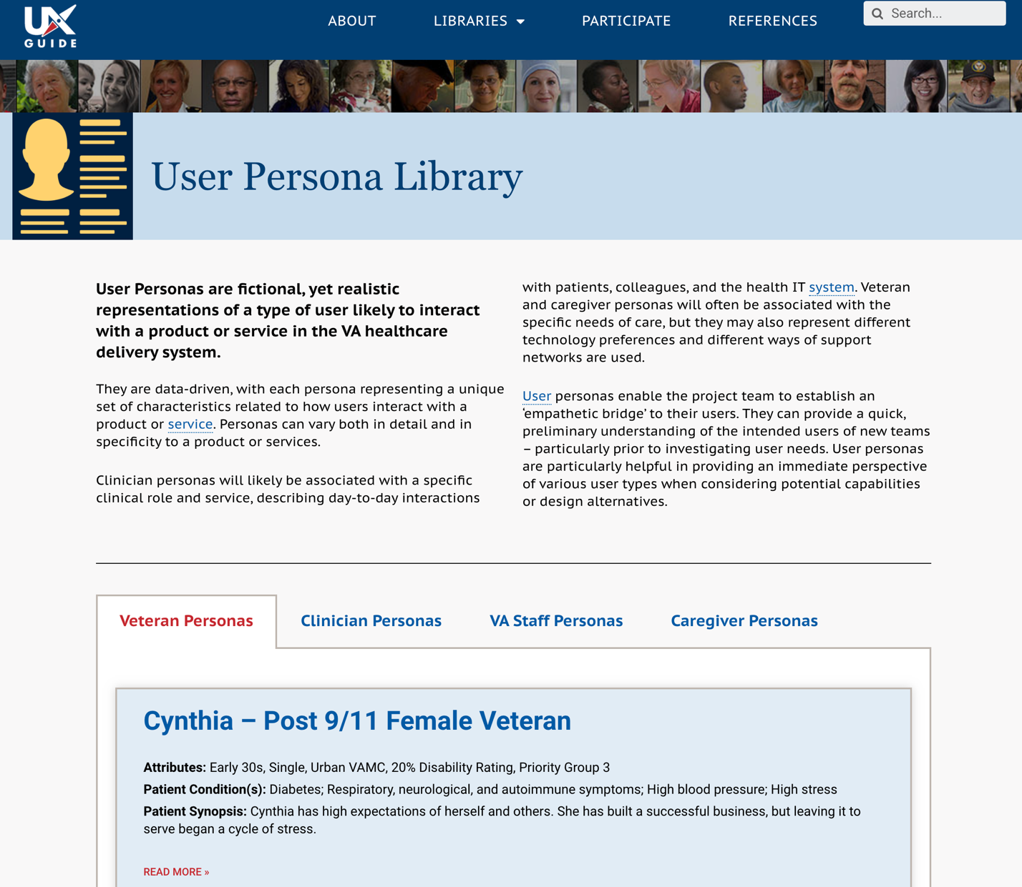

The intro content could be reorganized for better comprehension, and we could use bullets and bold to highlights key points.

Example:

**User personas are fictional, yet realistic representations of a type of user likely to interact with a product or service in the VA healthcare delivery system.**

[User](https://veteransaffairsuxguide.com/glossary/user/) personas enable the project team to establish an “empathetic bridge” to their users. They can provide a quick, preliminary understanding of the intended users of new teams – particularly prior to investigating user needs.

* They are **data-driven**, with each persona representing a unique set of characteristics related to how users interact with a product or [service](https://veteransaffairsuxguide.com/glossary/service/).
* Personas can vary both in detail and in specificity to a product or services.
* Personas are particularly helpful in providing an immediate perspective of various user types when **considering potential capabilities or design alternatives**.

**Clinician personas** will likely be associated with a specific clinical role and service, describing day-to-day interactions with patients, colleagues, and the health IT [system](https://veteransaffairsuxguide.com/glossary/system/). **Veteran** and **caregiver personas** will often be associated with the specific needs of care, but they may also represent different technology preferences and different ways of support networks are used.

## Scenarios of Use Library

<https://veteransaffairsuxguide.com/libraries/scenarios-of-use/>

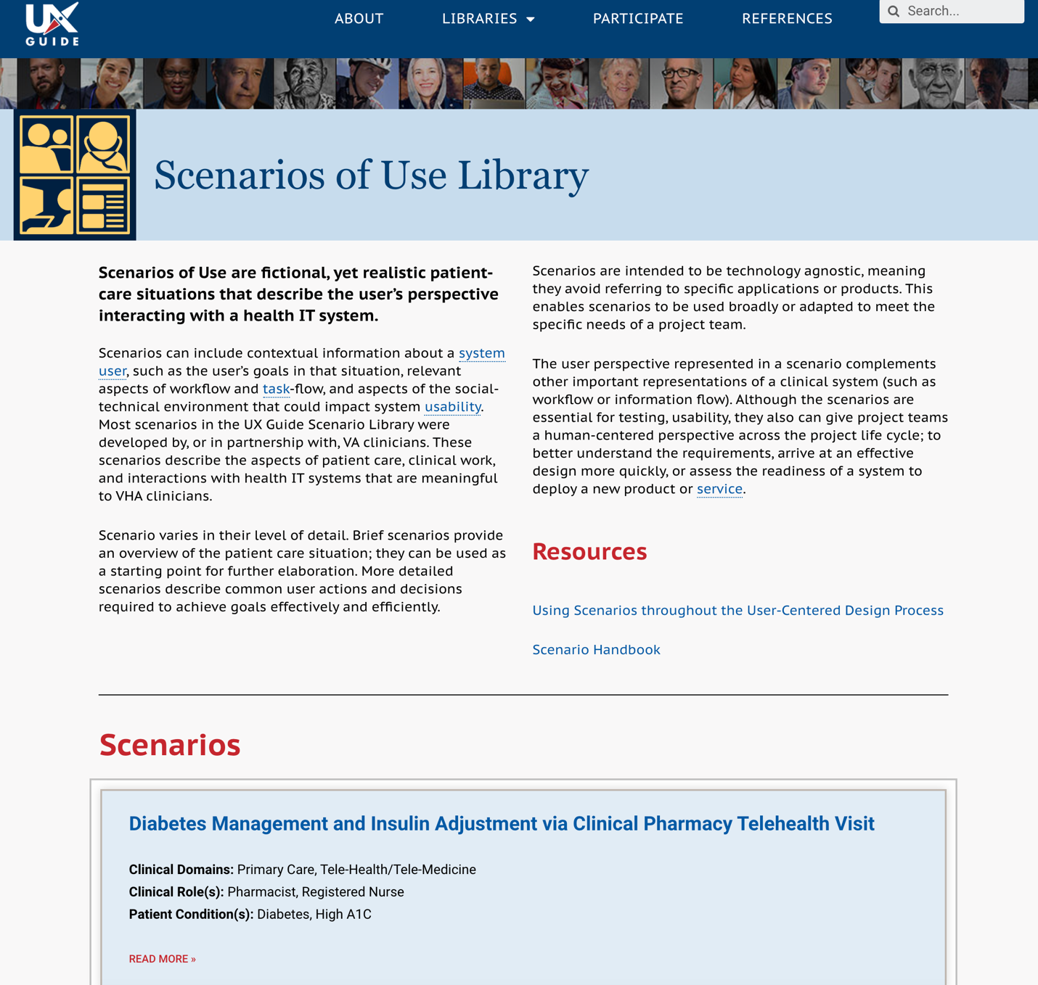

We can bullet key points and selectively use bold to make it easier to quickly see important details.

Example:

**Scenarios of Use are fictional, yet realistic patient-care situations that describe the user’s perspective interacting with a health IT system.**

Scenarios can include:

* Contextual information about a [system](https://veteransaffairsuxguide.com/glossary/system/) [user](https://veteransaffairsuxguide.com/glossary/user/), such as the user’s goals in that situation
* Relevant aspects of workflow and [task](https://veteransaffairsuxguide.com/glossary/task/)-flow
* Aspects of the social-technical environment that could impact system [usability](https://veteransaffairsuxguide.com/glossary/usability/)

Most scenarios in the UX Guide Scenario Library were developed by, or in partnership with, VA clinicians. These scenarios describe the aspects of patient care, clinical work, and interactions with health IT systems that are meaningful to VHA clinicians.

Scenario varies in their level of detail. **Brief scenarios** provide an overview of the patient care situation; they can be used as a starting point for further elaboration. More **detailed scenarios** describe common user actions and decisions required to achieve goals effectively and efficiently.

Scenarios are intended to be technology agnostic, meaning they avoid referring to specific applications or products. This enables scenarios to be used broadly or adapted to meet the specific needs of a project team.

The user perspective represented in a scenario complements other important representations of a clinical system (such as workflow or information flow). Although the scenarios are essential for testing and usability, they also can give project teams a human-centered perspective across the project life cycle; to better understand the requirements, arrive at an effective design more quickly, or assess the readiness of a system to deploy a new product or [service](https://veteransaffairsuxguide.com/glossary/service/).

## Methods Library

<https://veteransaffairsuxguide.com/libraries/methods-library/>

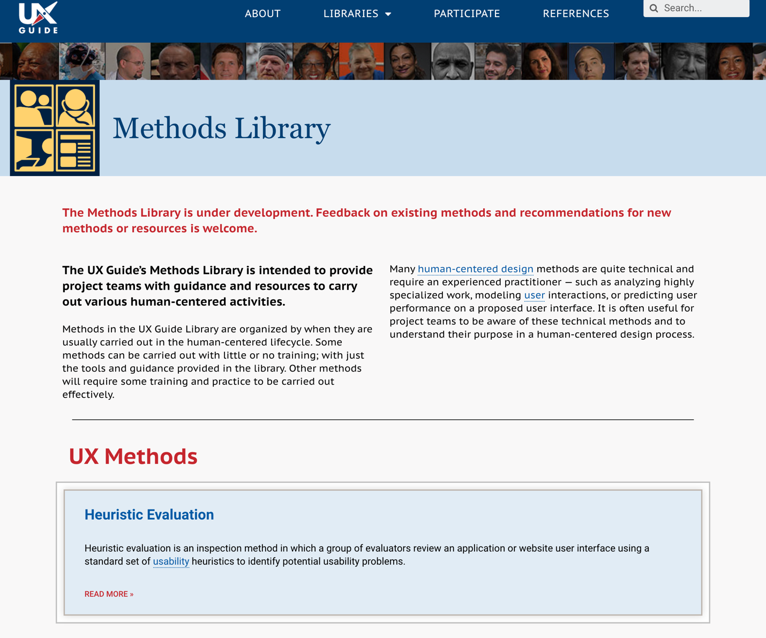

We could bullet the content in the intro text to make it easier to pull out the key points.

Example:

**The UX Guide’s Methods Library is intended to provide project teams with guidance and resources to carry out various human-centered activities.**

* These methods are organized by when they are usually carried out in the human-centered lifecycle.
* Some can be carried out with little or no training, with just the tools and guidance provided in the library.
* Other methods will require some training and practice to be carried out effectively.

Many [human-centered design](https://veteransaffairsuxguide.com/glossary/human-centered-design/) methods are quite technical and require an experienced practitioner — such as analyzing highly specialized work, modeling [user](https://veteransaffairsuxguide.com/glossary/user/) interactions, or predicting user performance on a proposed user interface. It is often useful for project teams to be aware of these technical methods and to understand their purpose in a human-centered design process.

## Heuristic Evaluation

<https://veteransaffairsuxguide.com/method/heuristic-evaluation/>

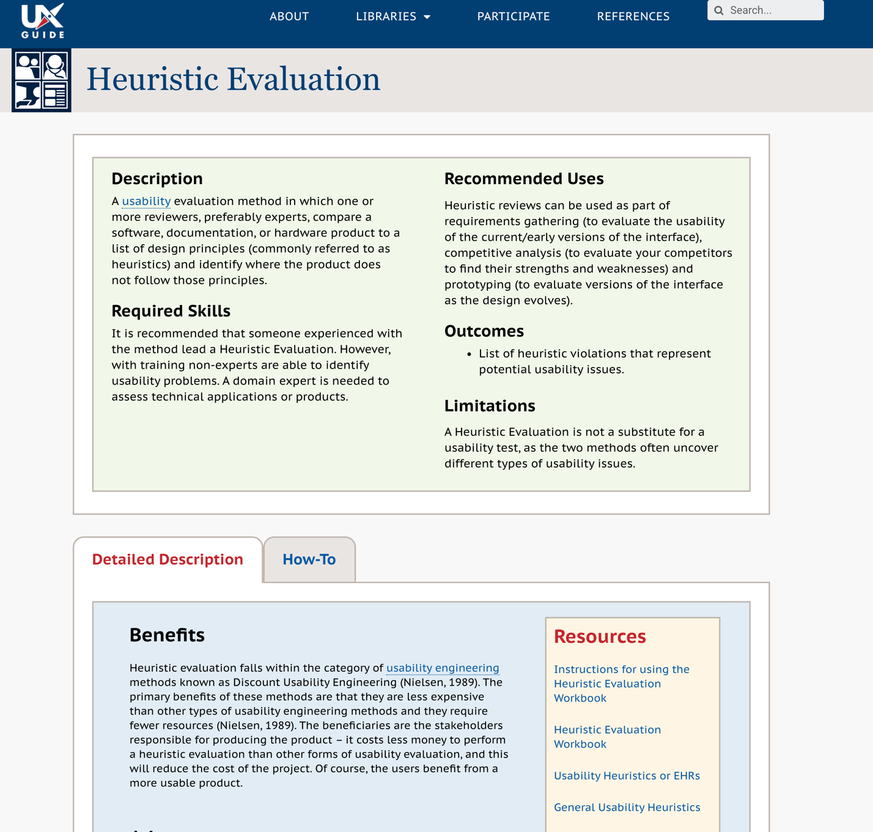

Bulleting the text in the intro will help highlight the key points.

**Example:**

**Description**

A [usability](https://veteransaffairsuxguide.com/glossary/usability/) evaluation method in which one or more reviewers, preferably experts, compare a software, documentation, or hardware product to a list of design principles (commonly referred to as heuristics) and identify where the product does not follow those principles.

**Required Skills**

* We recommend that someone experienced with the method lead a heuristic evaluation.
* With training non-experts are able to identify usability problems.
* A domain expert is needed to assess technical applications or products.

**Recommended Uses**

Heuristic reviews can be used as part of:

* Requirements gathering (to evaluate the usability of the current/early versions of the interface)
* Competitive analysis (to evaluate your competitors to find their strengths and weaknesses)
* Prototyping (to evaluate versions of the interface as the design evolves)

**Outcomes**

* List of heuristic violations that represent potential usability issues.

**Limitations**

* Not a substitute for a usability test, as the two methods often uncover different types of usability issues.